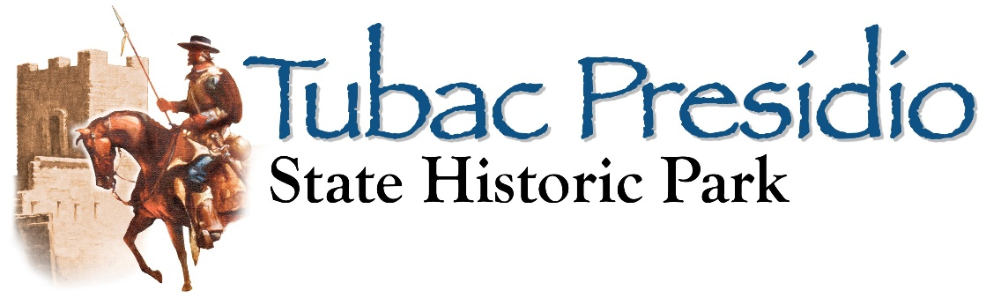1Burruel Street • P.O. Box1296 • Tubac, AZ 85646
(520) 398-2252 • FAX 398-2685 • TubacPresidio.org

Booklet printed thanks to a grant from the Country Fair White Elephant organization.
Junior Ranger Journal
Tubac Presidio State Historic Park
Now operated by VOLU NTEERS under the di rection of Friends of the Presidio
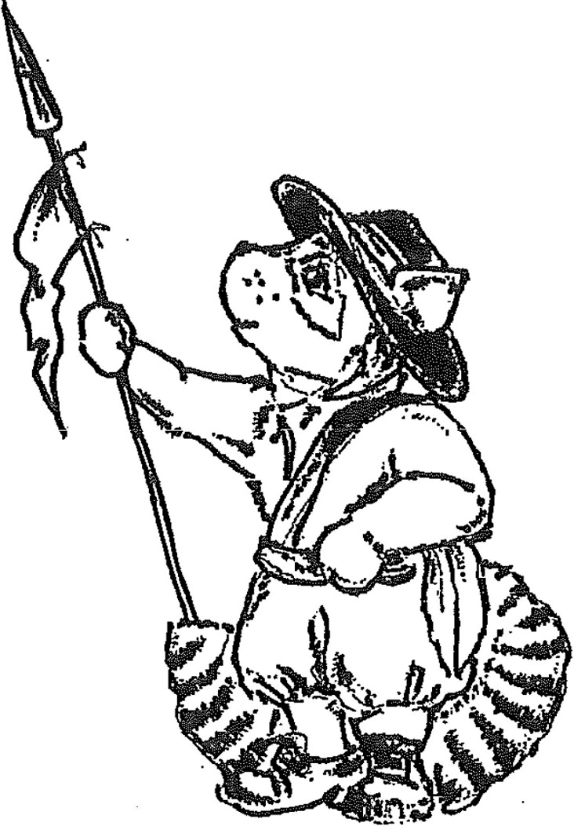1 Burruel Street, Tubac, Arizona 85646 · 520.398.2252 ·www.TubacPresidio.org

You can become a junior ranger if you:
- Are between 6 and 12 years old.
- Complete as many of the questions as you can.
Then bring your journal to the desk to be checked. You'll receive a special Tubac Presidio State Historic Park badge making you a Junior Ranger.

By becoming a Junior Ranger at the Tubac Presidio, you are pledging to do your part to learn some of the history that makes Arizona special.

Map of

As a
Tubae Presid io State Park Junior Ranger I pledge to do my part to
learn about Arizona's f ascinating past.
Learning about the past helps us understand our f uture.

I wi ll share what I learn with my f riends and f amily.
Tubac Presidio State Histor ic Park

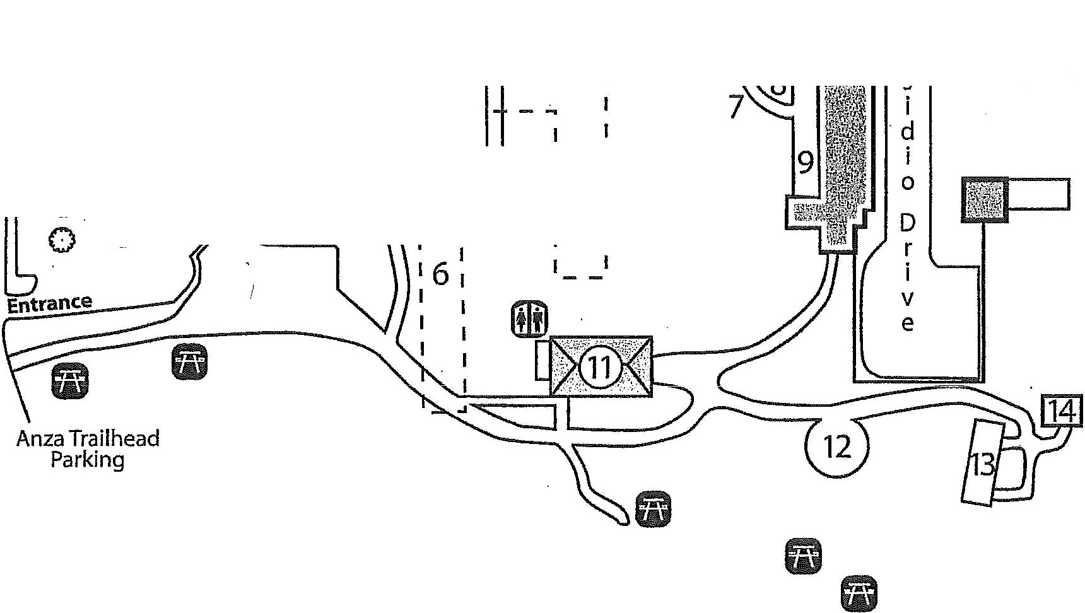Calle Iglesia """""--
B
u
r
0 - - - ,
r

p N

e r - - ..
1 4 -
I
0 I I
s om I
5 I I
0
t. I 6 I
0 I

l Junior Ranger's Signature

1. Visitor Center
- 1885 Schoolhouse
- St. Ann's Church not on park grounds
- Former Captain's House & Presidio Headquarters (Casa del Capitan y Cuartel)
- Entrance to archaeological excavation exhibit
- Location of Presidio (Fort)
- Arrastra - grinding ore
8. Molinas - grinding stones

9. Interpretive Area
10. Museum
11. Otero Hall
- Rojas Plaza
- Rojas House
- Tack Room
Legend
fl) Parking
(fill Rest Rooms
fi Picnic Tables

Map not to scale
•::!> Please Recycle

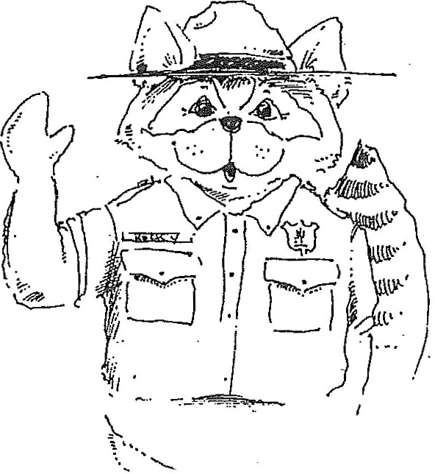Kids, as a Tubae Presidio State Historic Park Junior Ranger, you will be entitled
to free admission to the park when you're wearing your badge.

Thanks for sharing your knowledge with friends and family.

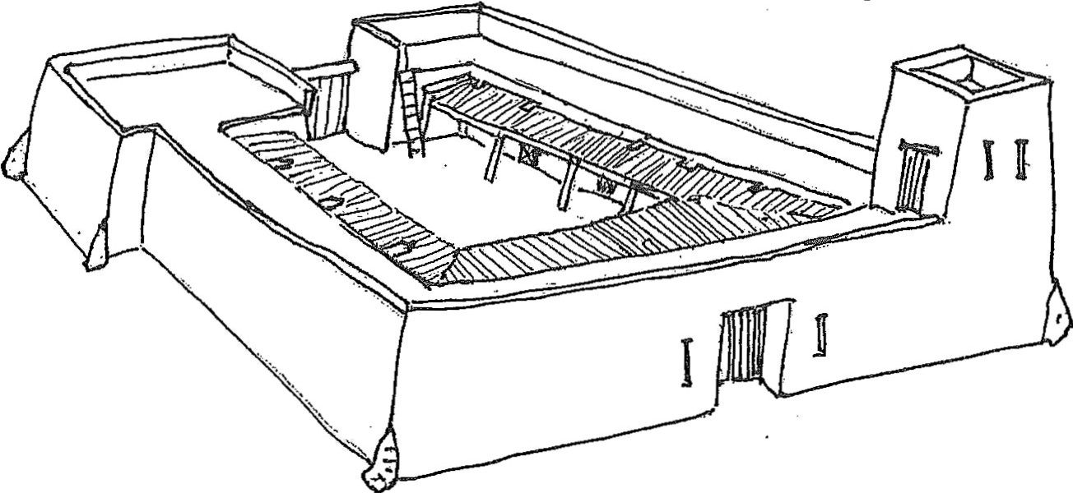

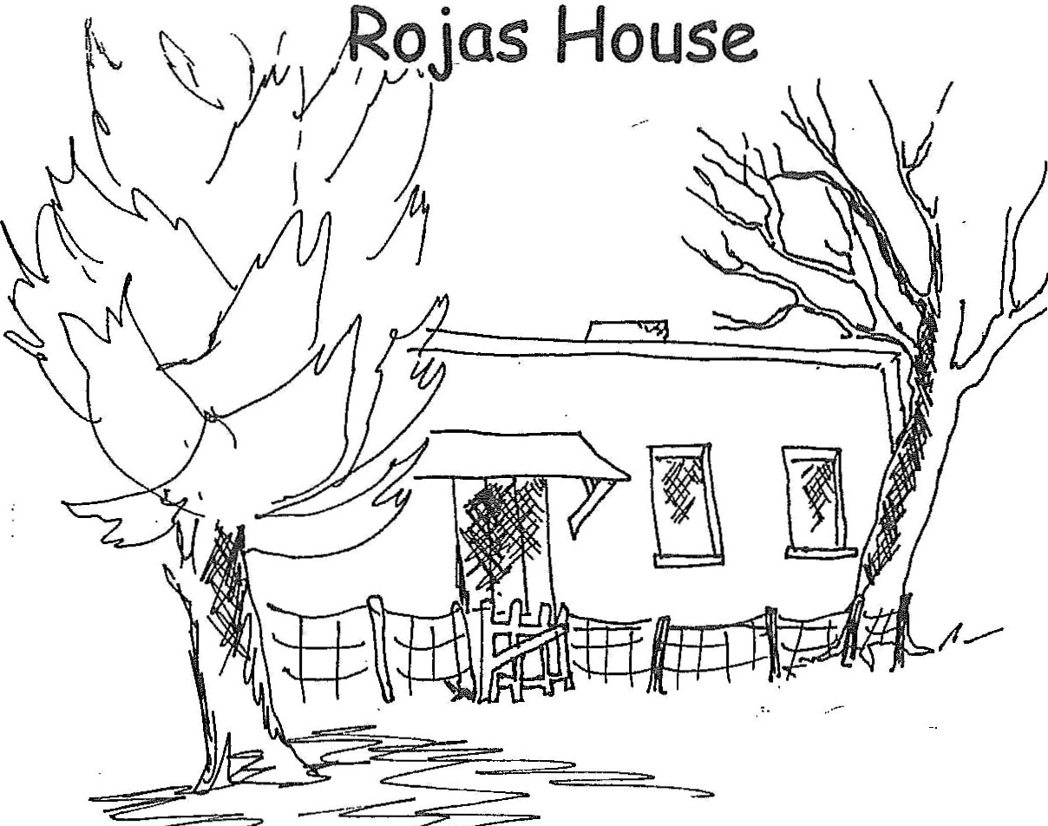This house was common to the area and was known as a"----------
- --..
Louisa Rojas lived her entire life here from 1894 until 1989. T F
This type of house.was popular because:
  - Easily built B. Easy to extend C. Mud floors
- D. All of the above Answer--------

Presidio Ruins and the Underground

Rocks outline the western portion of the Presidio. While you are in the underground exhibit, notice some of the objects found during the excavation (digging up the ruins), Name three artifacts (historic objects) discovered at the site. -----------------------
The teachers at the school warned the kids to not play on the walls. Do you think they did or did not play on the ruins? What clues gave you

Life in the Spanish Colony of Tubae

What would your life in Tubae be like in the 1700's? Life was different 200 years ago! Everything you had would have been made by hand. You would have had to make adobe blocks to build a house, raise your own garden and sheep for food, and sew your own clothes. Houses were small, usually only one room. ( t's hard work building with adobe, they didn't buildhouses any bigger than necessary!) Most of your family's activities were done outside.

Your father would have been a tradesman; building furniture, making leather goods, or he may have been a soldier. You see, Tubae was a presidio (military
- fort)! The soldier's job was to keep the Spanish settlers safe from ndian raids. The headquarters building of the pres idia was where the captain lived and was at the center of town. t was in the presidia that weddings, parties and other special events were held! Would you like to have lived here during those times? What would have been the best part? ---------

the answer?----------------------- The worst part? _

The Schoolhouse The Anza Expedition of 1775-1776

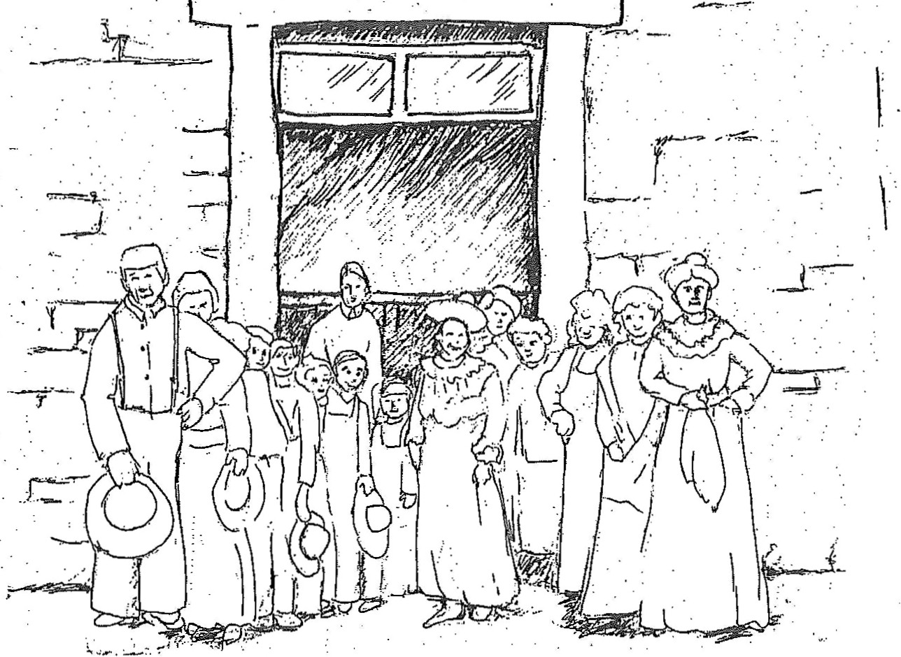As a member of the expedition, you are put in charge of making sure that everything that will be needed for the 5 month trip is ready. Circle the
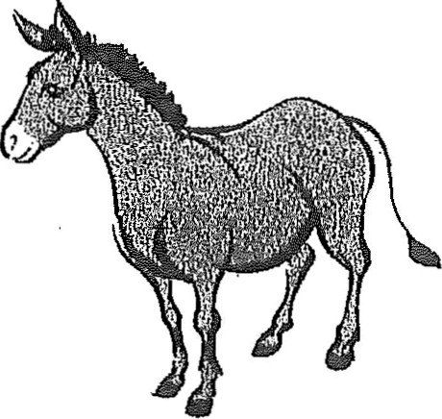items that you would take along.

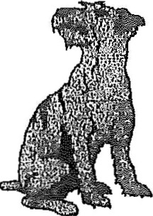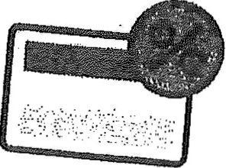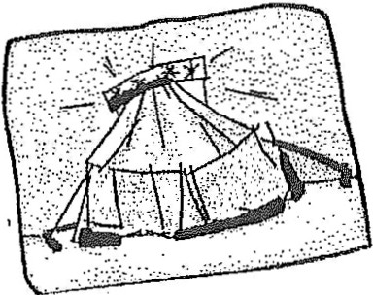

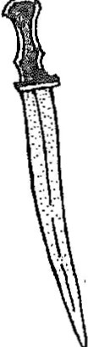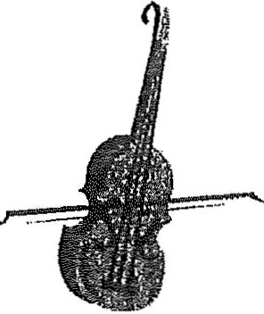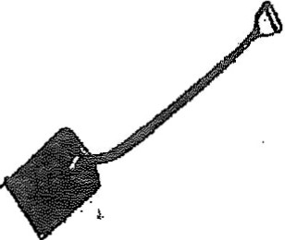Does this look like your school? All grades would have-been here with just 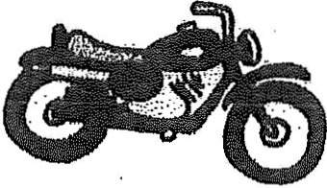 one teacher! What would have been the most fun part of attending a school
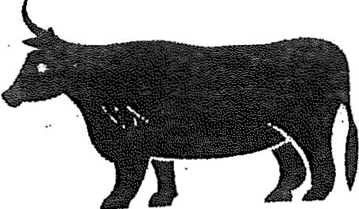like this? __ _ 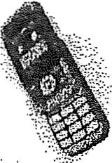
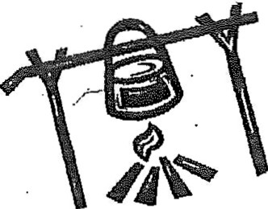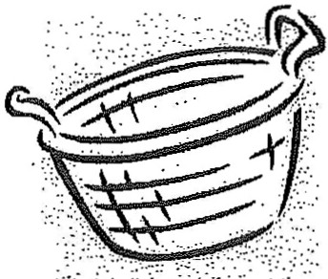Have a look at the rules written on the blackboard! Write the one you think is the strangest or funniest here: _ _

Look at the punishments on the blackboard! Which one is the weirdest?

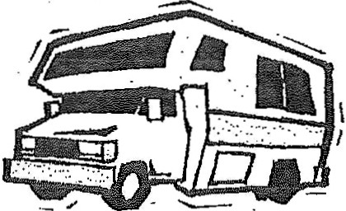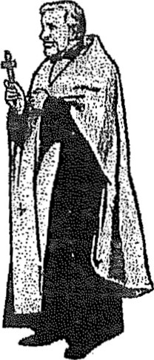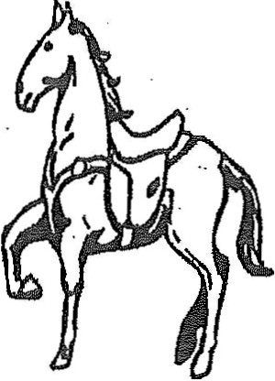One of the f irst schoolhouses in Arizona was built in Tubae. T_ F_ Punishment in those days was by the teacher giving:
A. Lashes B. Extra homework C.Timeouts
D. Bad grades Answer ----

Museum Hunt and Find
What was the system called that was used f or grinding ore? _ As you find these items in the museum, check them of f . Some are
rather tricky to find, so look caref ul ly!

The power used by this system was: A. Horses, B. Mules, C. People
D. A ll the above. Answer----
What were the stones called used f or grinding corn? _

piece of turquoise
sheII necklaces
silver chalice (tall glass)
cattle brands

copper pot
"strike-a-l ight"
top hat and its box
statue of Spanish priest

What time periods are exhibited in the Tubae Presidio Park?
photo of Sabino Otero small copper bell

A. Native Ind ian B. Spanish Colonial C. Mexican Republ ic
D. Territorial E. All the above Answer ----
cannon
printing press
--iron arrowhead
--Mescal knif e

Who was the Jesuit priest that established the Spanish Missions f rom 1691 to 1711? Father _

The event that triggered the need to establish a presidia in Tubae was?
A. Mexican War B. Civi l War C. Pima Upr ising Answer _
The 2nd Captain at the Tubae Presidio was Juan Bautista de Anza.T_F_ Y\'hat flag flew over Tubae f rom 1821 to 1854?-----------
The United States acquired Tubae by the Gadsden Purchase. T F
Cattle Brands
Brands have been used as marks of identif ication at some time in all
countries. In Ari zona, ranchers branded their livestock to prove ownership.
Think of a name f or "your" cattle ranch and design a brand so that you don't lose any of your animals.
The name of my ranch is --------------­ My ranch's brand is:

What minerals were mined in the Tubae area? A. Gold B. Si lver C. Lead
D. A ll the above Answer Some examples of brands:
-----
Circle T Lazy S
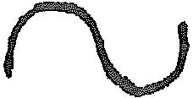The first newspaper in Arizona was the Tubae News. T F

Rising Star
A

Otero Hall
\ \ \ \ _Jj_- -I

A - MAZE-ING FUNI

\\ - I I
•' I.L,

Otero Hall was built in 1914 and was the center
of all special events in town. (Just like the presidio was in the 1750's!)
It's a good thing Rocky Ringtail remembered his map so he can f ind his way back to school. Start at the arrow and see if you can join him there.
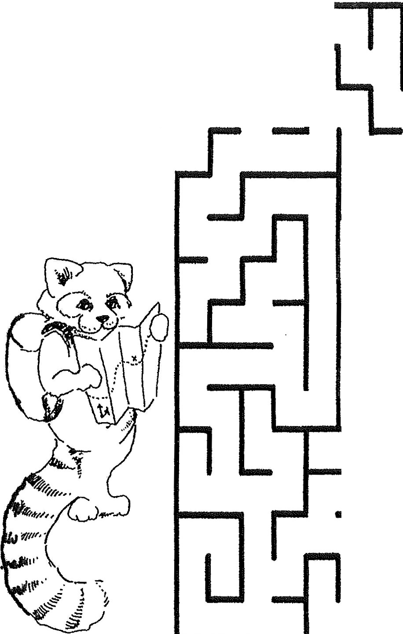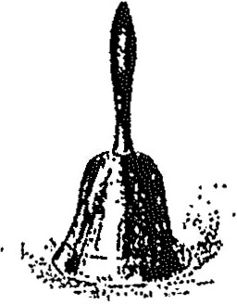-
•.

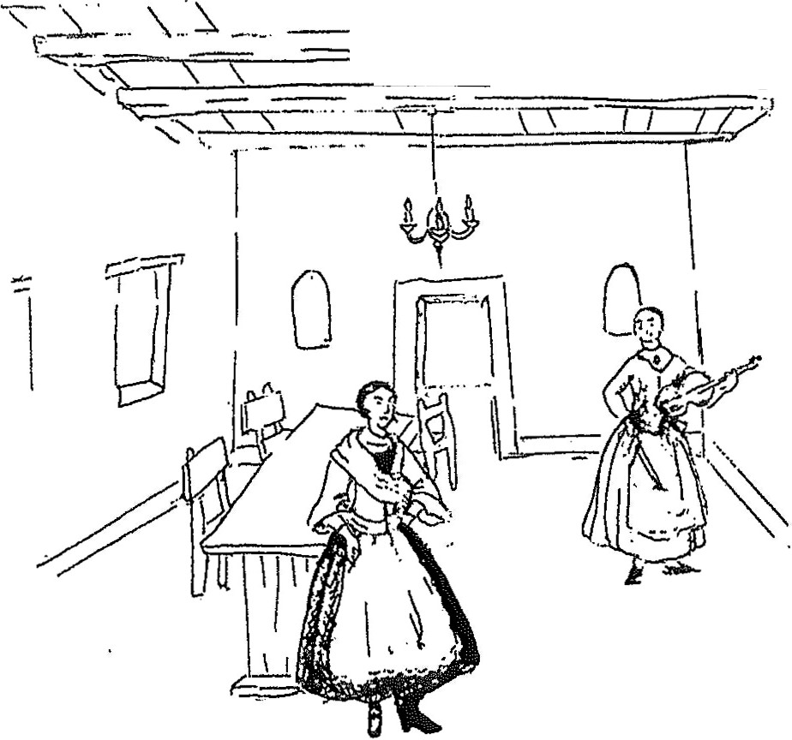'
'

During some events, the guests would throw coins out for the children to
pick up. f you were lucky enough to find a coin today, you'd have to leave it where it is because artifacts (human- made items from the past) are protected by law so that everyone can see them!

Name some events that would take place in the hall _

When Tubac's population increased, Ortero Hall was purchased to be used as a

Look at the exhibit hanging in the hall. Each shows something interesting about the history of Arizona. Which is your favorite? _

Why did you choose that one? _

